WEBSITE TRAFFIC ANALYSIS AND CONVERSION RATE PREDICTION
Prepared By
Dixita vasireddy

ABSTRACT
Website traffic analysis plays a critical role in understanding user behavior, optimizing digital marketing strategies, and improving conversion performance. This project focuses on analyzing website traffic data using exploratory data analysis techniques and machine learning models.
The dataset contains information related to page views, session duration, bounce rate, traffic source, time spent on pages, previous visits, and conversion rates. Various statistical and visualization techniques were used to identify patterns in website visitor behavior. Additionally, machine learning models were developed to predict conversion rates based on user engagement metrics.
The findings provide valuable insights into visitor behavior and highlight the factors that most strongly influence conversion performance.

1. INTRODUCTION
Modern businesses rely heavily on websites to attract customers, generate leads, and increase revenue. Understanding website traffic behavior is essential for improving user experience and maximizing conversions.
Website analytics provides information about visitor engagement, browsing patterns, and marketing effectiveness. By analyzing website traffic data, organizations can identify areas for improvement and make data-driven decisions.
This project aims to analyze website traffic data and develop predictive models capable of estimating conversion rates based on user behavior metrics.

2. OBJECTIVES
The objectives of this project are:
- To analyze website traffic patterns.
- To identify relationships between user engagement metrics and conversions.
- To visualize traffic characteristics using statistical plots.
- To evaluate the impact of bounce rate, page views, and session duration.
- To build machine learning models for conversion rate prediction.
- To compare model performance using evaluation metrics.
- To provide actionable recommendations for improving website performance.

3. DATASET DESCRIPTION
The dataset contains website visitor activity and engagement information.
Dataset Features
Feature | Description
Page Views | Number of pages viewed during a session
Session Duration | Total duration of user session
Bounce Rate | Percentage indicating single-page visits
Traffic Source | Source of website traffic
Time on Page | Time spent on individual pages
Previous Visits | Number of previous visits by user
Conversion Rate | Percentage representing conversion success
Dataset Overview
The dataset contains both numerical and categorical variables suitable for statistical analysis and machine learning.

4. DATA PREPROCESSING
Data preprocessing was performed to ensure data quality before analysis.
Missing Value Analysis
The dataset was examined for missing values.

Duplicate Record Analysis
Duplicate records were checked to avoid bias in analysis.
Result: 0
Screenshot
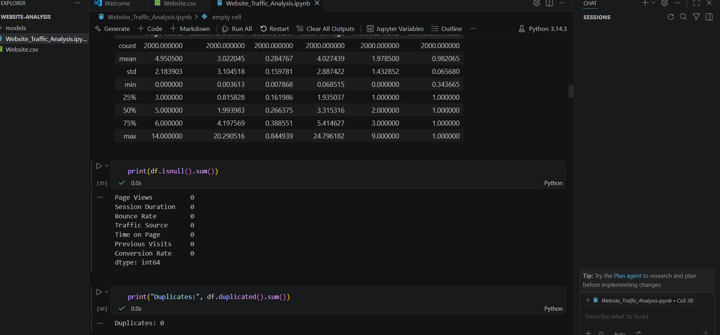

5. EXPLORATORY DATA ANALYSIS (EDA)
Exploratory Data Analysis was performed to understand the distribution of variables and relationships among website metrics.

5.1 Distribution Analysis
Histograms were used to understand the distribution of numerical variables.
Screenshot
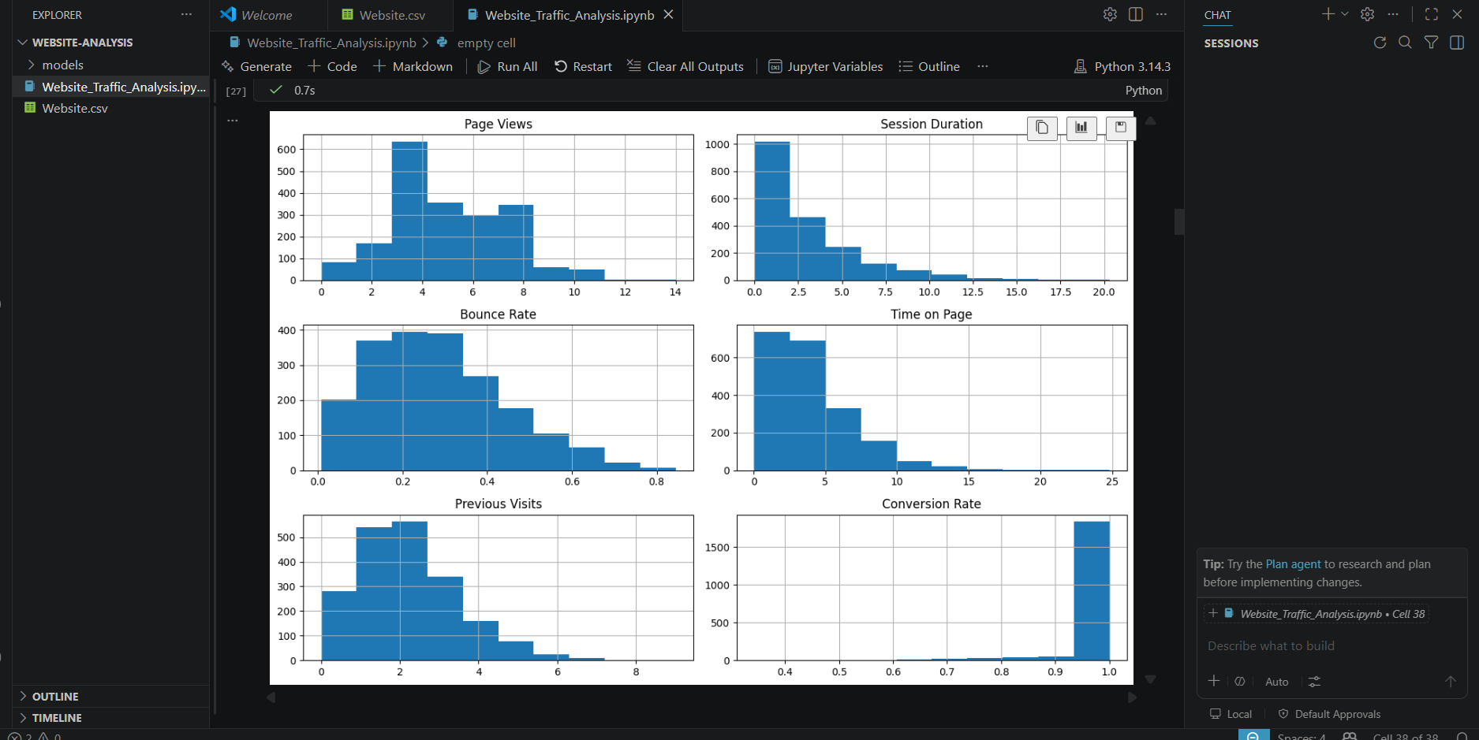
Observation
The distributions provide insights into visitor engagement behavior and traffic characteristics.

5.2 Traffic Source Distribution
Traffic sources were analyzed to identify the most common acquisition channels.
Screenshot
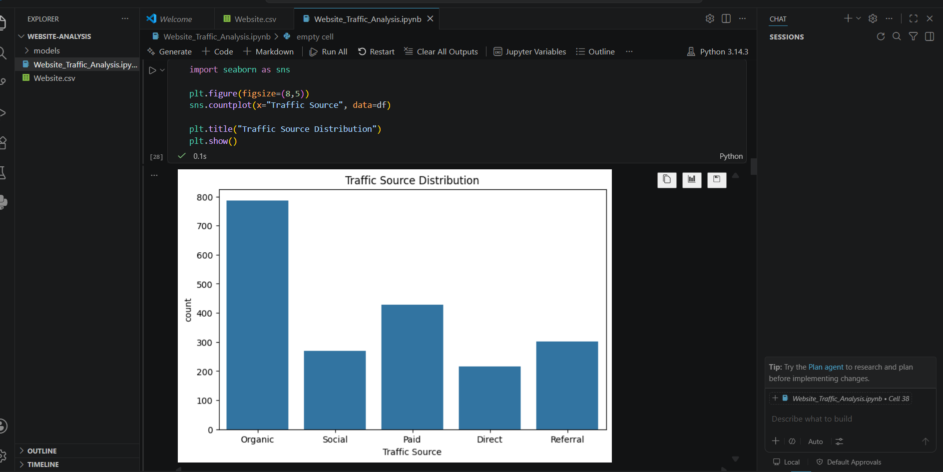
Observation
Different traffic sources contribute differently to overall website traffic.

5.3 Page Views vs Conversion Rate
The relationship between page views and conversion rate was examined.
Screenshot
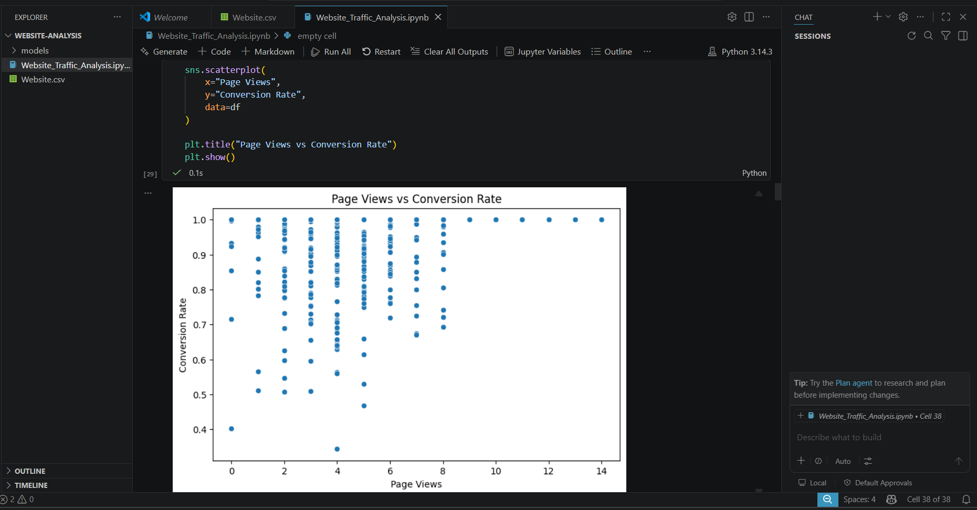
Observation
Visitors with higher page views often show different conversion patterns compared to low-engagement visitors.

5.4 Session Duration vs Conversion Rate
Session duration was analyzed against conversion rate.
Screenshot
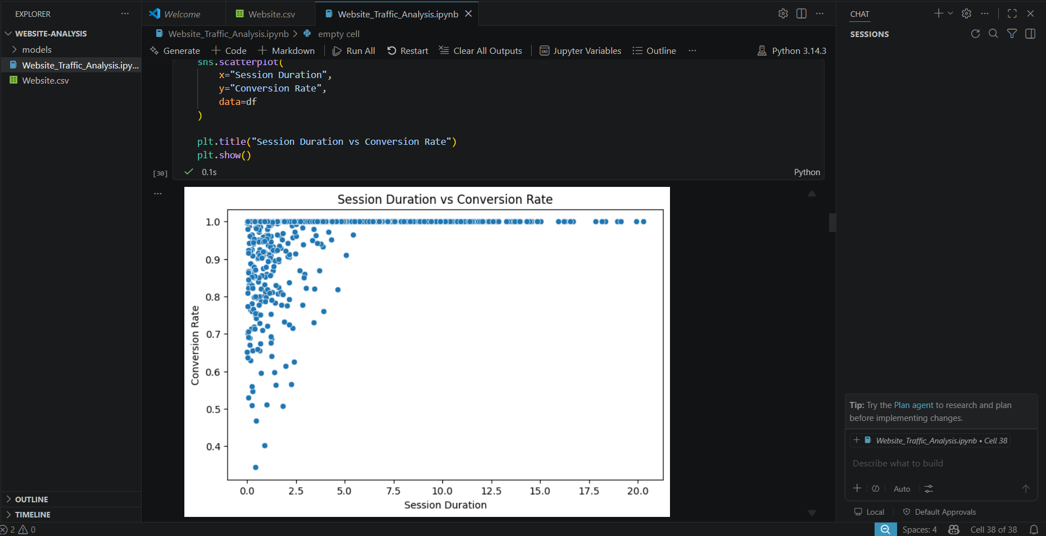
Observation
Longer session durations may indicate stronger user engagement and higher conversion probability.

5.5 Bounce Rate vs Conversion Rate
Bounce rate was evaluated against conversion performance.
Screenshot
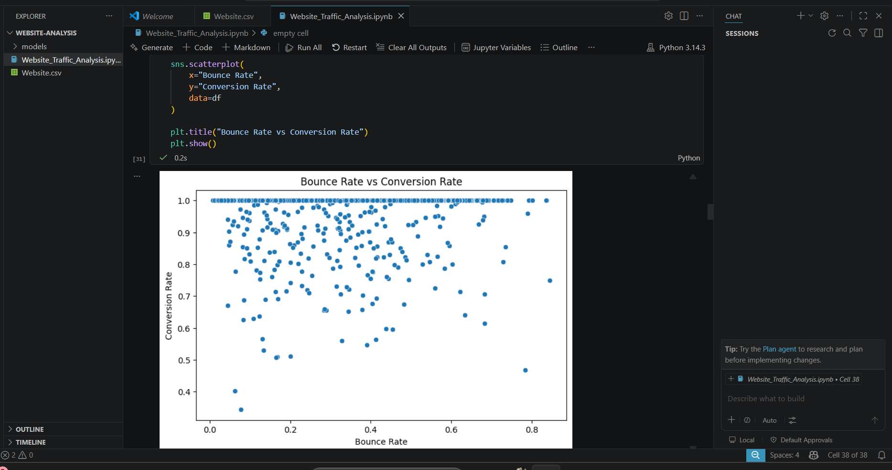
Observation
Higher bounce rates are generally associated with lower conversion performance.

5.6 Correlation Analysis
A correlation heatmap was generated to identify relationships among variables.
Screenshot
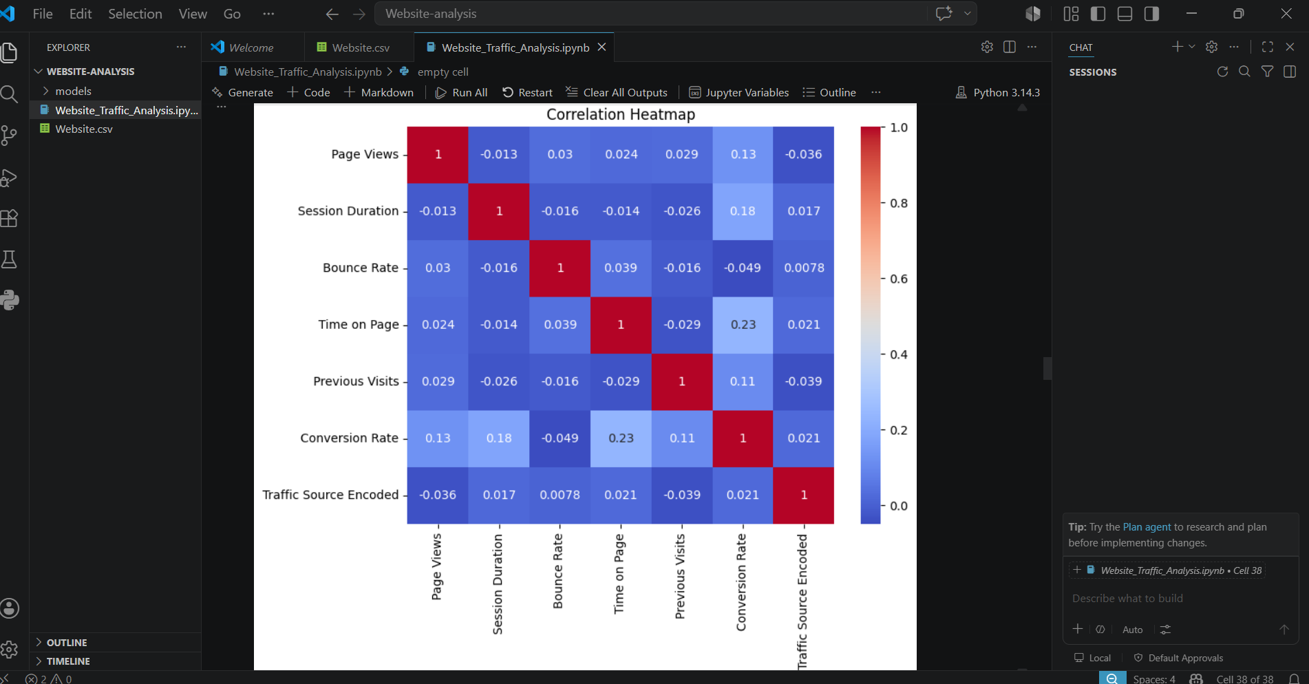
Observation
The heatmap highlights positive and negative correlations among user behavior metrics.

6. FEATURE ENGINEERING
To build predictive models, relevant input features and target variables were selected.
Input Features
- Page Views
- Session Duration
- Bounce Rate
- Time on Page
- Previous Visits
Target Variable
- Conversion Rate
The selected features represent key indicators of user engagement and website performance.

7. MACHINE LEARNING MODEL DEVELOPMENT
Machine learning models were developed to predict conversion rates.
The dataset was divided into training and testing sets.
Training Data
(1600,5)
Testing Data
(400,5)

8. LINEAR REGRESSION MODEL
Linear Regression was implemented as a baseline predictive model.
Performance Metrics
MAE:
0.03154065224112423
RMSE:
0.05277947303203079
R² Score:
0.10794639998041977
Analysis
Linear Regression establishes a linear relationship between user engagement metrics and conversion rate.

9. RANDOM FOREST REGRESSOR
Random Forest Regressor was implemented to capture complex nonlinear relationships.
Performance Metrics
MAE:
0.022200719014448058
RMSE:
0.050720141541766545
R² Score:
0.17620004411289925
Analysis
Random Forest combines multiple decision trees to improve prediction accuracy and reduce overfitting.

10. GRADIENT BOOSTING REGRESSOR
Gradient Boosting Regressor was implemented as an advanced ensemble learning model.
Performance Metrics
MAE:
0.0225116092641397
RMSE:
0.049801735055912455
R² Score:
0.20576358031835018
Analysis
Gradient Boosting improves predictive performance by sequentially correcting model errors.

11. MODEL COMPARISON
Model | MAE | RMSE | R² Score
Linear Regression | 0.0315 | 0.0528 | 0.1079
Random Forest | 0.0222 | 0.0507 | 0.1762
Gradient Boosting | 0.0225 | 0.0498 | 0.2058
Best Performing Model
Gradient Boosting
The best-performing model achieved the highest R² score and lowest prediction errors.

12. CROSS VALIDATION
Cross-validation was performed to evaluate model reliability.
Cross Validation Scores
[0.21242973 0.34794758 0.25621429 0.12813781 0.303238 ]
Average Cross Validation Score
0.24959348245614682
Analysis
Cross-validation demonstrates the model's ability to generalize across different subsets of data.

13. FEATURE IMPORTANCE ANALYSIS
Feature importance analysis was performed using the Random Forest model.
Screenshot
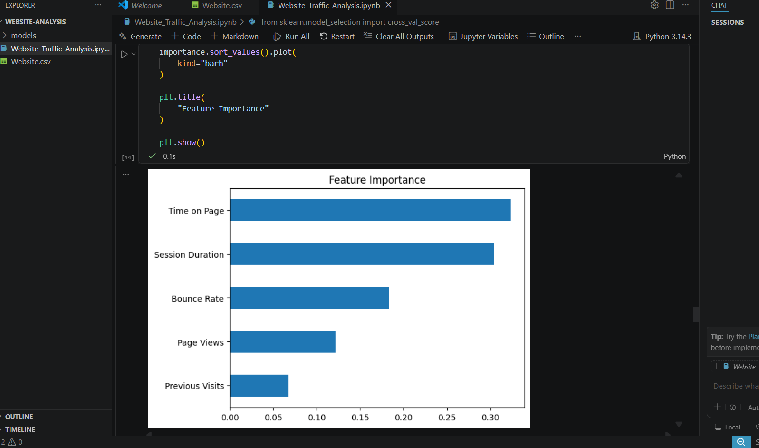
Observation
The analysis identifies the variables that most strongly influence conversion rate prediction.

14. ACTUAL VS PREDICTED ANALYSIS
Actual conversion values were compared with predicted values.
Screenshot
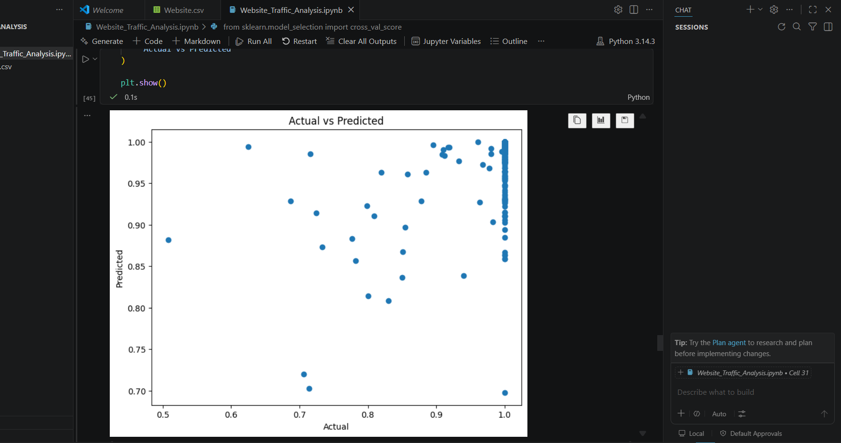
Observation
A closer alignment between actual and predicted values indicates better model performance.

15. RESIDUAL ANALYSIS
Residual analysis was conducted to evaluate prediction errors.
Screenshot
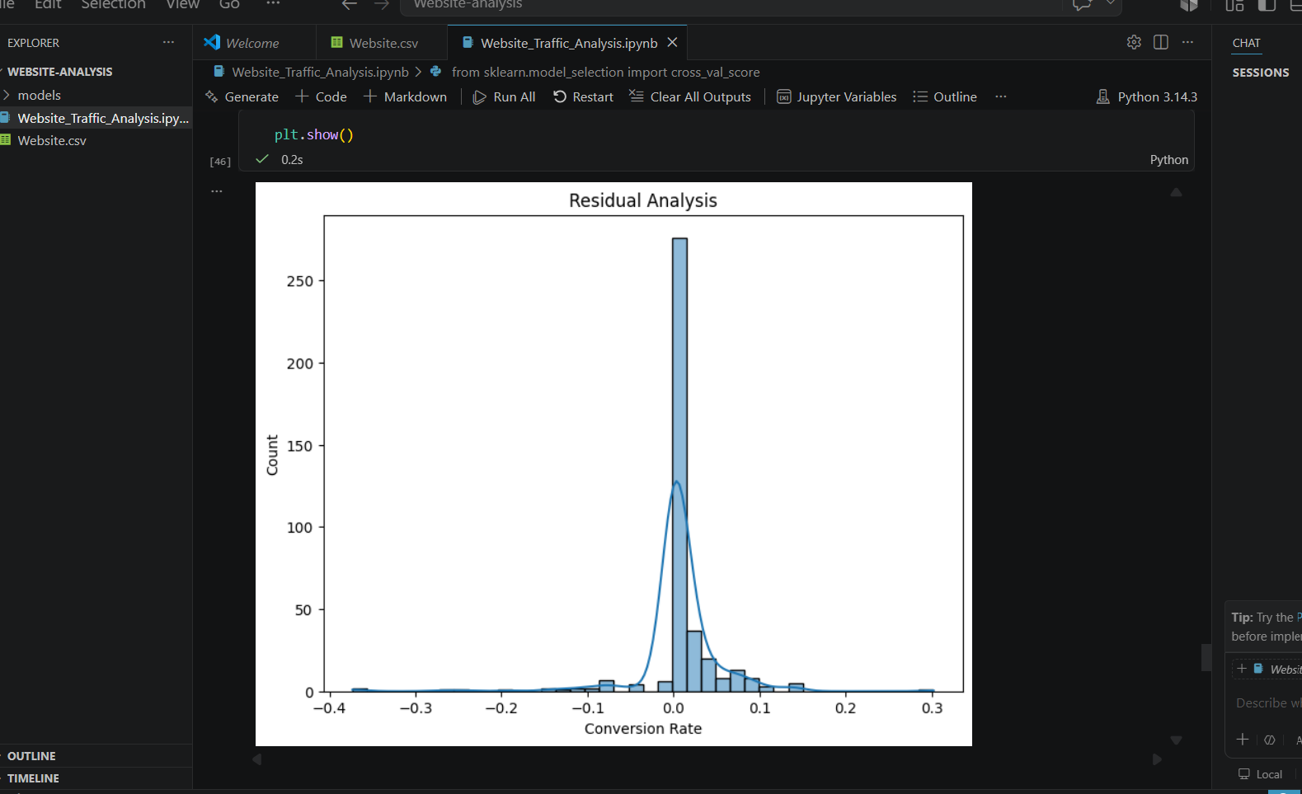
Observation
Residuals help determine whether prediction errors are randomly distributed.

16. LEARNING CURVE ANALYSIS
Learning curves were generated to evaluate model learning behavior.
Screenshot
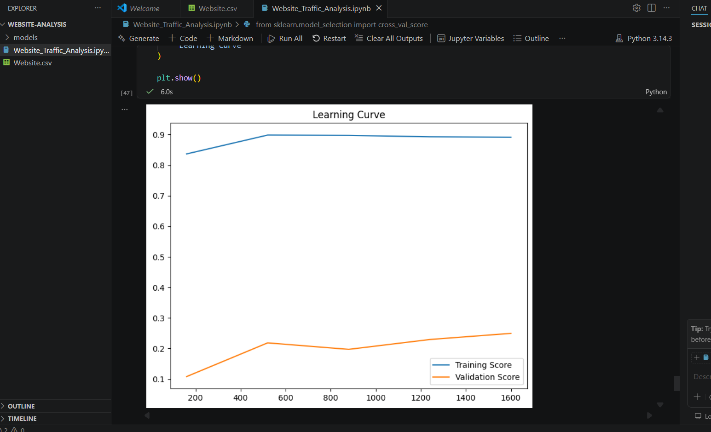
Observation
Learning curves provide insights into model bias, variance, and data sufficiency.

17. KEY FINDINGS
- User engagement metrics significantly influence conversion rates.
- Session duration plays an important role in conversion performance.
- Bounce rate negatively impacts conversion outcomes.
- Traffic source affects visitor behavior and engagement.
- Returning visitors exhibit different conversion patterns than new visitors.
- Ensemble models performed better than basic linear models.
- Machine learning techniques can effectively predict website conversion rates.

18. BUSINESS RECOMMENDATIONS
- Improve content quality to reduce bounce rates.
- Optimize website navigation to increase page views.
- Enhance user experience to improve session duration.
- Focus marketing efforts on high-performing traffic sources.
- Implement personalized recommendations for returning visitors.
- Use predictive analytics to identify high-conversion visitor segments.
- Continuously monitor engagement metrics to improve conversion performance.

19. CONCLUSION
This project successfully analyzed website traffic data and developed machine learning models for conversion rate prediction.
Exploratory Data Analysis revealed important relationships between user engagement metrics and conversion performance. Multiple machine learning models were evaluated, and ensemble methods demonstrated superior predictive capability.
The insights generated from this analysis can help organizations improve website performance, optimize marketing strategies, and enhance conversion outcomes through data-driven decision-making.

REFERENCES
- Python Documentation
- Pandas Documentation
- NumPy Documentation
- Matplotlib Documentation
- Seaborn Documentation
- Scikit-Learn Documentation
- Website Traffic Dataset

